The Diffraction Grating
to
Measure the Wavelength of Light

Description
In this laboratory experiment we will use a diffraction grating to measure the wavelength of a HeNe laser.

Equipment Needed

Dell Laptop Computer (for graphs)
AC Adapter, Dell Laptop
Diffraction Grating, 100/300/600
Laser, HeNe ~670nm
AC Adapter, Laser HeNe
Viewing Screen, w/2 binder clips Pasco OS-8460
Jack, Table Silver
Meter Stick (2)
Optics Track, Pasco OS-8508
Rubber Band

Introduction
The diffraction grating consists of a large number of equally spaced parallel slits. A grating can be made by cutting parallel lines on a glass plate with a precision ruling machine. In a transmission grating, the space between any two lines is transparent to the light and hence acts as a separate slit. A grating with 100 slits per millimeter has a slit spacing
.
The gratings we will use in this lab have three windows per slide. They are generally 100, 300, and 600 lines per millimeter. You will need to calculate d for the 300 and 600 lines per millimeter windows.
Figure 1 demonstrates the geometry of light after it has passed through the diffraction grating. We show just two of the slits for simplicity of illustration.
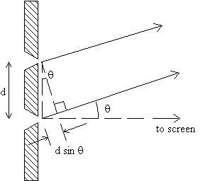
Figure 1

Figure 2 shows the geometry between the grating and the screen. The pictured angle as shown denotes the second maxima. This is the same as shown in Figure 1. There is a 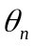 for each 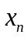.

Figure 2
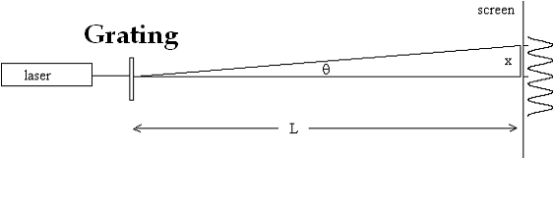
Figure 3 combines Figure 1 and Figure 2.
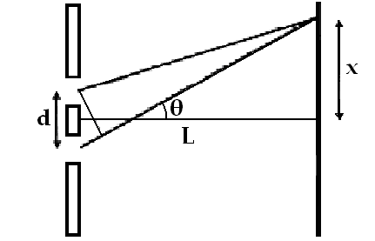
Figure 3
To show where the maxima are created we need to know the value of
.
This value was illustrated in Figure 1. Since this is the difference in distance of the two light beams from the two slits to the screen we will expect a maxima to appear at this point. Note: The maxima occur when the difference in distances equals a multiple of the wavelength of the light. We also know that this difference will be equal to one multiple of the wavelength between the two beams so
Equation 1
We know that
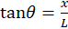 Equation 2
We can find the beam length using the identity (Pythagorean Theorem)
Equation 3
Then solving for h (beam length) we get
Equation 4
Also
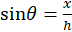 Equation 5
Substituting Equation 4 into Equation 5 we find
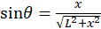 Equation 6
We can now substitute Equation 6 into Equation 1 and we get
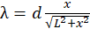 Equation 7
When the first maxima occurs we know that Equation 7 equals 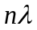 where 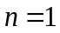. We can substitute this into Equation 7 and we get
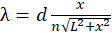 Equation 8
In Equation 8 we have established measurable variables with which to calculate the wavelength of the light beam.
Safety
Although these lasers are not particularly dangerous, we should take a few simple precautions to prevent the unlikely event of eye damage.
- Never look directly into the laser beam. Laser light has a high intensity and can also be easily focused. A direct shot of the laser beam on your eye will be focused by your cornea onto a small spot on your retina and can burn or possibly detach the retina.
- Never hold a reflecting object by hand in front of the laser beam. This prevents the possibility of accidentally shining the light into your eyes.
- Keep your head above the plane of the laser beam.
- Whenever the light strikes an object, there will be a reflection. At times the reflections can be almost as strong as the incident beam. Know where the reflections are and block them if necessary.
- The laser has a shutter in front of the beam. When not taking data, place the shutter in front of the laser beam.

Procedure

Figure 4 Setup and Layout
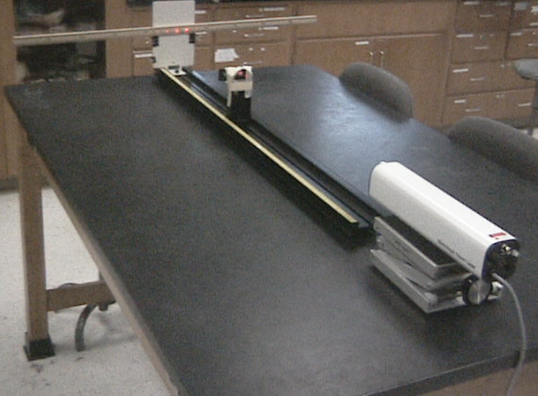
- Set up your lab similar to Figure 4.
- Line up the laser to hit the meter stick on the 50 cm point. The distance from the laser to the screen is not critical.
- Set the grating with the 100 lines / mm window between the laser and the screen. Note: When handling the gratings be careful not to touch the window.
- Make geometric adjustments. Refer to Figure 5.
  - Vertical—where the dot measurements are easy to read.
  - Horizontal—scatter the dots as much as possible by increasing the value of L. You can move the grating closer and farther from the screen.
Figure 5 Dot array (typical)
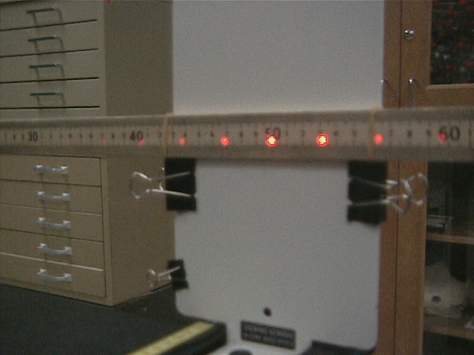
- Record the distance values.
  - Once you establish the L distance set it should stay the same for all of the x’s. Record this distance.
  - Record the distances x of the light dots from the 50 cm mark on the meter stick.
- Repeat the steps 3, 4, and 5 for the 300 and 600 line/mm windows on the diffraction grating. You may notice that the distance L must be readjusted for each window.
Data Tables
Grating Window 100lines/mm
 | L= | d=
n | X | Calculated
1
2
3
4
5
6
7
8
9
10
 | Average

Note: You will be limited in the number dots you can get with the denser gratings. The instructor may not choose to take data from all three gratings on the card.
Grating Window 300lines/mm
 | L= | d=
n | X | Calculated
1
2
3
4
5
 | Average

Grating Window 600lines/mm
 | L= | d=
n | X | Calculated
1
2
3
4
5
 | Average

Graph
Rewrite Equation 8
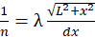 Equation 9
Create a graph for each of the diffraction gratings.
Use a trend line and find the slope of the curves.
Using the slope, find the % error.

